Jupy Tools
Jupyter Notebook
September 9, 2026
Kernel: Python 3.10 • Code cells: 50 • Markdown cells: 3 • Lines: 354
Generated by Jupy Tools — free, private, in-browser

Table of contents

In [1]:
import pandas as pd
import numpy as np
import matplotlib.pyplot as plt
import seaborn as sns

In [2]:
from sklearn.model_selection import train_test_split
from sklearn.preprocessing import MinMaxScaler #Normalization

In [3]:
df = pd.read_csv('train1.csv')

In [4]:
# Dataset dimensions
print("Number of rows:", df.shape[0])
print("Number of columns:", df.shape[1])

# Dataset information
df.info()

# Statistical summary of numerical variables
df.describe()
Output:
Number of rows: 891
Number of columns: 12
<class 'pandas.core.frame.DataFrame'>
RangeIndex: 891 entries, 0 to 890
Data columns (total 12 columns):
# Column Non-Null Count Dtype
--- ------ -------------- -----
0 PassengerId 891 non-null int64
1 Survived 891 non-null int64
2 Pclass 891 non-null int64
3 Name 891 non-null object
4 Sex 891 non-null object
5 Age 714 non-null float64
6 SibSp 891 non-null int64
7 Parch 891 non-null int64
8 Ticket 891 non-null object
9 Fare 891 non-null float64
10 Cabin 204 non-null object
11 Embarked 889 non-null object
dtypes: float64(2), int64(5), object(5)
memory usage: 83.7+ KB

PassengerId
Survived
Pclass
Age
SibSp
Parch
Fare

count
891.000000
891.000000
891.000000
714.000000
891.000000
891.000000
891.000000

mean
446.000000
0.383838
2.308642
29.699118
0.523008
0.381594
32.204208

std
257.353842
0.486592
0.836071
14.526497
1.102743
0.806057
49.693429

min
1.000000
0.000000
1.000000
0.420000
0.000000
0.000000
0.000000

25%
223.500000
0.000000
2.000000
20.125000
0.000000
0.000000
7.910400

50%
446.000000
0.000000
3.000000
28.000000
0.000000
0.000000
14.454200

75%
668.500000
1.000000
3.000000
38.000000
1.000000
0.000000
31.000000

max
891.000000
1.000000
3.000000
80.000000
8.000000
6.000000
512.329200

In [5]:
# Identify numerical and categorical columns

numerical_columns = df.select_dtypes(include=np.number).columns
categorical_columns = df.select_dtypes(include=['object']).columns

print("Numerical columns:")
print(list(numerical_columns))

print("\nCategorical columns:")
print(list(categorical_columns))
Output:
Numerical columns:
['PassengerId', 'Survived', 'Pclass', 'Age', 'SibSp', 'Parch', 'Fare']

Categorical columns:
['Name', 'Sex', 'Ticket', 'Cabin', 'Embarked']

In [6]:
# Missing-value analysis

missing_count = df.isnull().sum()
missing_percentage = (df.isnull().mean() * 100).round(2)

missing_summary = pd.DataFrame({
'Missing Count': missing_count,
'Missing Percentage': missing_percentage
})

missing_summary = missing_summary[missing_summary['Missing Count'] > 0]

missing_summary.sort_values(
by='Missing Percentage',
ascending=False
)
Output:
Missing Count
Missing Percentage

Cabin
687
77.10

Age
177
19.87

Embarked
2
0.22

Missing Value Analysis

The dataset contains missing observations in Age, Cabin and Embarked.

Cabin contains a very high proportion of missing values (approximately 77.10%), making direct imputation unreliable. Therefore, the Cabin column is removed.

Age contains approximately 19.87% missing observations. Since Age is a numerical variable, the missing values are imputed using a central tendency measure.

Embarked contains only a very small number of missing observations and is imputed using the mode because it is a categorical variable.

In [7]:
df.drop(columns=['Cabin'],inplace=True)

In [8]:
df['Age'] = df['Age'].fillna(df['Age'].mean())

In [9]:
df.head()
Output:
PassengerId
Survived
Pclass
Name
Sex
Age
SibSp
Parch
Ticket
Fare
Embarked

0
1
0
3
Braund, Mr. Owen Harris
male
22.0
1
0
A/5 21171
7.2500
S

1
2
1
1
Cumings, Mrs. John Bradley (Florence Briggs Th...
female
38.0
1
0
PC 17599
71.2833
C

2
3
1
3
Heikkinen, Miss. Laina
female
26.0
0
0
STON/O2. 3101282
7.9250
S

3
4
1
1
Futrelle, Mrs. Jacques Heath (Lily May Peel)
female
35.0
1
0
113803
53.1000
S

4
5
0
3
Allen, Mr. William Henry
male
35.0
0
0
373450
8.0500
S

In [10]:
df['Embarked'] = df['Embarked'].fillna(df['Embarked'].mode()[0])

print("Missing values in Embarked:", df['Embarked'].isnull().sum())

# Display category distribution
print(df['Embarked'].value_counts())
Output:
Missing values in Embarked: 0
Embarked
S 646
C 168
Q 77
Name: count, dtype: int64

In [11]:
df['Embarked'].value_counts()
Output:
Embarked
S 646
C 168
Q 77
Name: count, dtype: int64

In [12]:
# EDA
# Target Variable Analysis

print("Survival counts:")
print(df['Survived'].value_counts())

print("\nSurvival percentages:")
print(
(df['Survived'].value_counts(normalize=True) * 100).round(2)
)
Output:
Survival counts:
Survived
0 549
1 342
Name: count, dtype: int64

Survival percentages:
Survived
0 61.62
1 38.38
Name: proportion, dtype: float64

In [13]:
plt.figure(figsize=(7,5))

sns.countplot(
data=df,
x='Survived'
)

plt.title('Distribution of Survival')
plt.xlabel('Survived (0 = No, 1 = Yes)')
plt.ylabel('Number of Passengers')

plt.show()
Output:
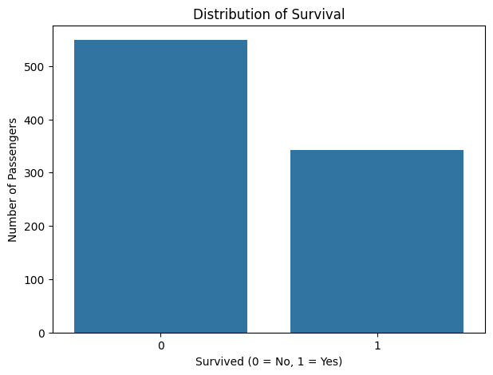

In [14]:
plt.figure(figsize=(7,5))

sns.countplot(
data=df,
x='Sex',
hue='Survived'
)

plt.title('Survival Distribution by Gender')
plt.xlabel('Gender')
plt.ylabel('Number of Passengers')

plt.show()
Output:
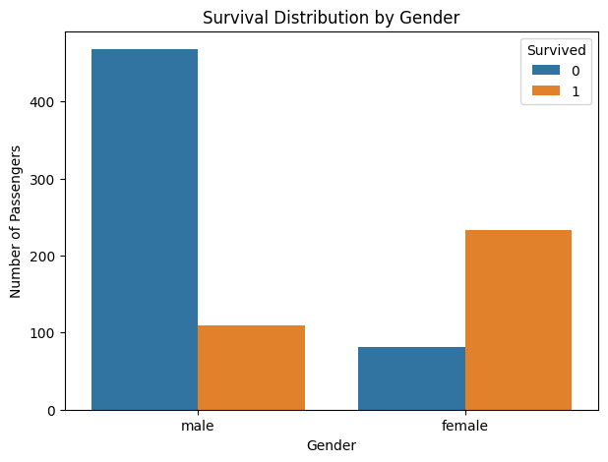

In [15]:
gender_survival = (
df.groupby('Sex')['Survived']
.mean()
.mul(100)
.round(2)
)

print("Survival percentage by gender:")
print(gender_survival)
Output:
Survival percentage by gender:
Sex
female 74.20
male 18.89
Name: Survived, dtype: float64

In [16]:
plt.figure(figsize=(8,5))

sns.countplot(
data=df,
x='Pclass',
hue='Survived'
)

plt.title('Survival Distribution by Passenger Class')
plt.xlabel('Passenger Class')
plt.ylabel('Number of Passengers')

plt.show()
Output:
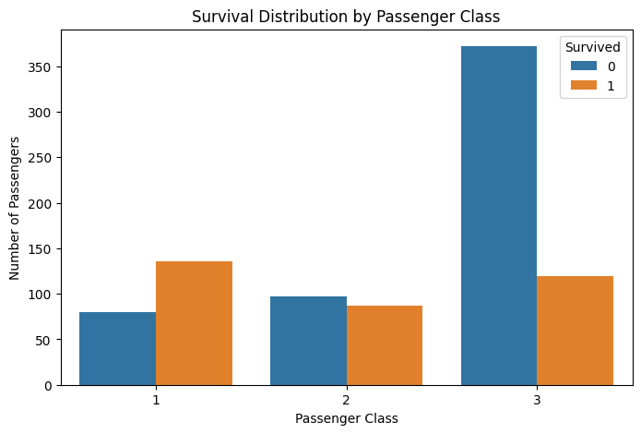

In [17]:
class_survival = (
df.groupby('Pclass')['Survived']
.mean()
.mul(100)
.round(2)
)

print("Survival percentage by passenger class:")
print(class_survival)
Output:
Survival percentage by passenger class:
Pclass
1 62.96
2 47.28
3 24.24
Name: Survived, dtype: float64

In [18]:
plt.figure(figsize=(8,5))

sns.countplot(
data=df,
x='Embarked',
hue='Survived'
)

plt.title('Survival Distribution by Port of Embarkation')
plt.xlabel('Embarkation Port')
plt.ylabel('Number of Passengers')

plt.show()
Output:
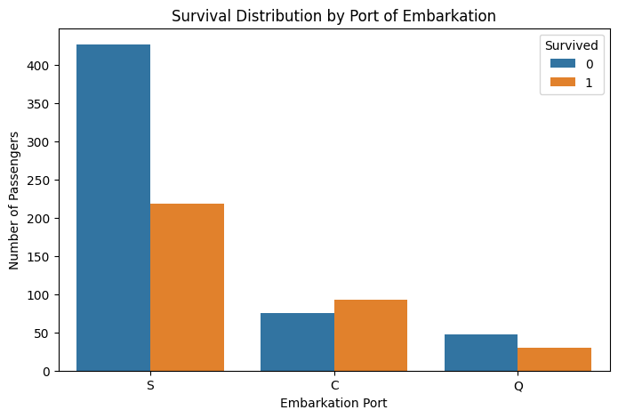

In [19]:
embarked_survival = (
df.groupby('Embarked')['Survived']
.mean()
.mul(100)
.round(2)
)

print("Survival percentage by embarkation port:")
print(embarked_survival)
Output:
Survival percentage by embarkation port:
Embarked
C 55.36
Q 38.96
S 33.90
Name: Survived, dtype: float64

In [20]:
print("Age Statistics")
print("----------------")
print("Minimum Age:", df['Age'].min())
print("Maximum Age:", df['Age'].max())
print("Mean Age:", round(df['Age'].mean(), 2))
print("Median Age:", round(df['Age'].median(), 2))
print("Standard Deviation:", round(df['Age'].std(), 2))
print("Skewness:", round(df['Age'].skew(), 2))
Output:
Age Statistics
----------------
Minimum Age: 0.42
Maximum Age: 80.0
Mean Age: 29.7
Median Age: 29.7
Standard Deviation: 13.0
Skewness: 0.43

In [21]:
plt.hist(df['Age'],bins=5)
Output:
(array([100., 523., 188., 69., 11.]),
array([ 0.42 , 16.336, 32.252, 48.168, 64.084, 80. ]),
<BarContainer object of 5 artists>)
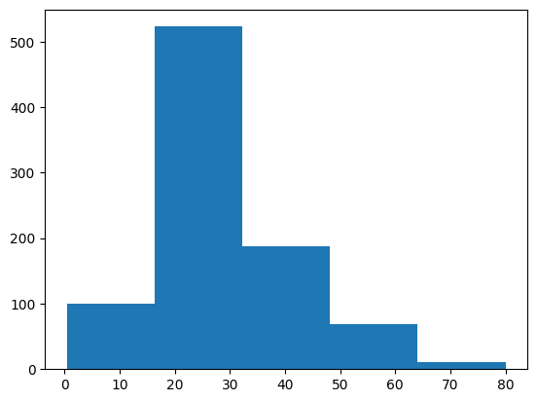

In [22]:
sns.histplot(df['Age'],kde=True)
Output:
<Axes: xlabel='Age', ylabel='Count'>
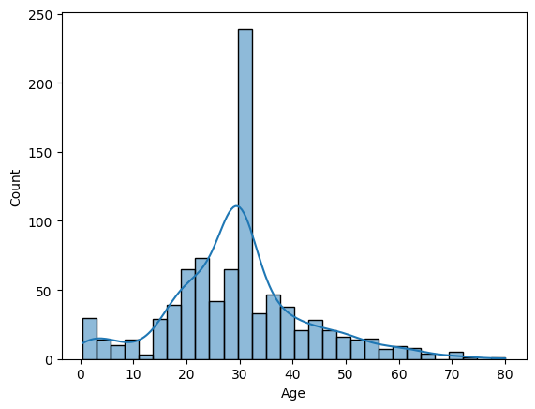

In [23]:
sns.boxplot(df['Age'])
Output:
<Axes: ylabel='Age'>
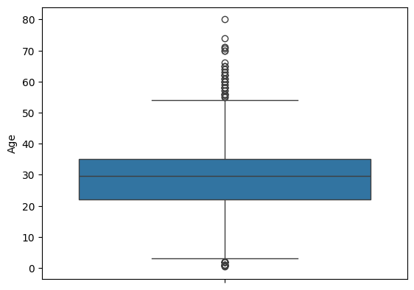

In [24]:
plt.figure(figsize=(8,5))

sns.boxplot(
data=df,
x='Survived',
y='Age'
)

plt.title('Age Distribution by Survival Status')
plt.xlabel('Survived (0 = No, 1 = Yes)')
plt.ylabel('Age')

plt.show()
Output:
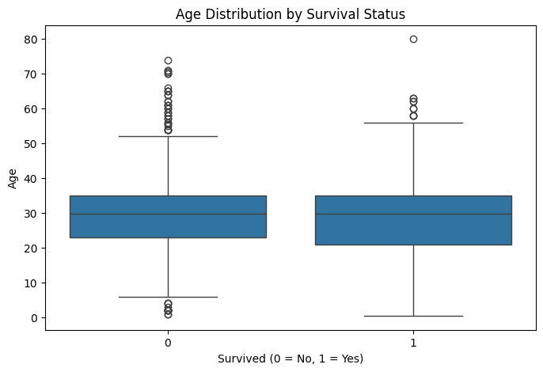

In [25]:
print(
df.groupby('Survived')['Age']
.agg(['count', 'mean', 'median', 'min', 'max'])
.round(2)
)
Output:
count mean median min max
Survived
0 549 30.42 29.7 1.00 74.0
1 342 28.55 29.7 0.42 80.0

In [26]:
plt.figure(figsize=(8,5))

sns.histplot(
data=df,
x='Fare',
kde=True
)

plt.title('Distribution of Passenger Fare')
plt.xlabel('Fare')
plt.ylabel('Frequency')

plt.show()
Output:
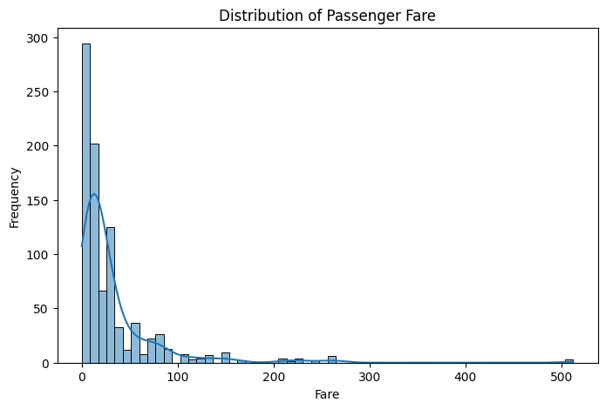

In [27]:
print(
df['Fare'].describe()
)
Output:
count 891.000000
mean 32.204208
std 49.693429
min 0.000000
25% 7.910400
50% 14.454200
75% 31.000000
max 512.329200
Name: Fare, dtype: float64

In [28]:
plt.figure(figsize=(8,5))

sns.boxplot(
data=df,
x='Survived',
y='Fare'
)

plt.title('Fare Distribution by Survival Status')
plt.xlabel('Survived')
plt.ylabel('Fare')

plt.show()
Output:
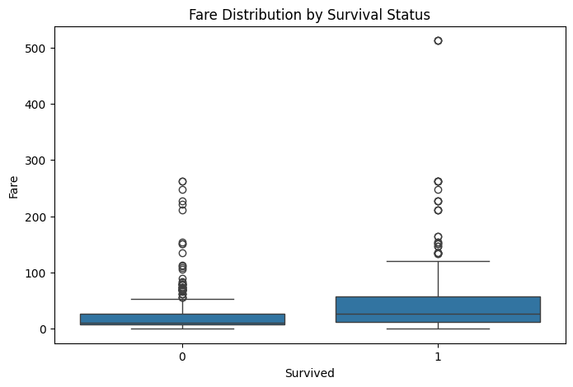

In [29]:
# Correlation Analysis

numeric_df = df.select_dtypes(include=np.number)

correlation_matrix = numeric_df.corr()

plt.figure(figsize=(10,7))

sns.heatmap(
correlation_matrix,
annot=True,
fmt='.2f',
cmap='coolwarm'
)

plt.title('Correlation Matrix of Numerical Features')

plt.show()
Output:
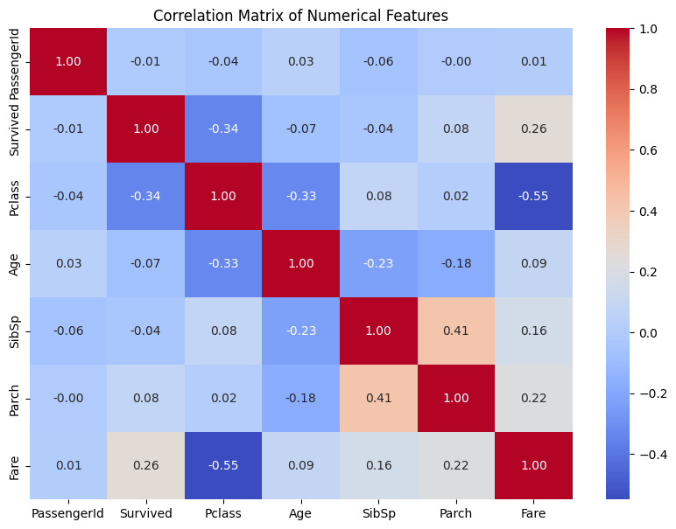

In [30]:
# Outlier analysis
plt.figure(figsize=(8,5))

sns.boxplot(
data=df[['Age', 'Fare']]
)

plt.title('Boxplot of Age and Fare')

plt.show()
Output:
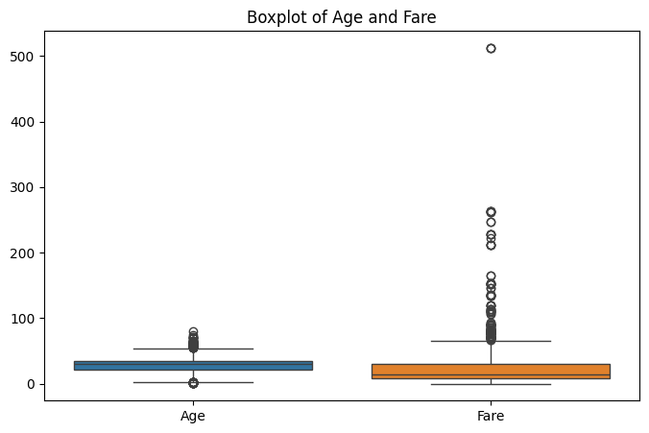

In [31]:
plt.figure(figsize=(8,4))

sns.boxplot(x=df['Age'])

plt.title('Age Outlier Analysis')
plt.xlabel('Age')

plt.show()
Output:
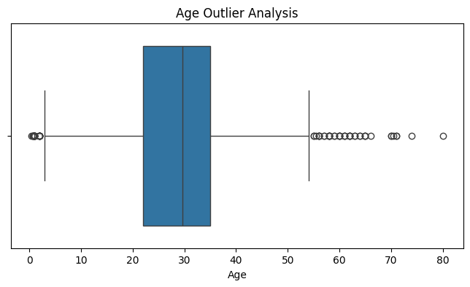

In [32]:
df['FamilySize'] = df['SibSp'] + df['Parch'] + 1

df[['SibSp', 'Parch', 'FamilySize']].head()
Output:
SibSp
Parch
FamilySize

0
1
0
2

1
1
0
2

2
0
0
1

3
1
0
2

4
0
0
1

In [33]:
plt.figure(figsize=(10,5))

sns.countplot(
data=df,
x='FamilySize',
hue='Survived'
)

plt.title('Survival Distribution by Family Size')
plt.xlabel('Family Size')
plt.ylabel('Number of Passengers')

plt.show()
Output:
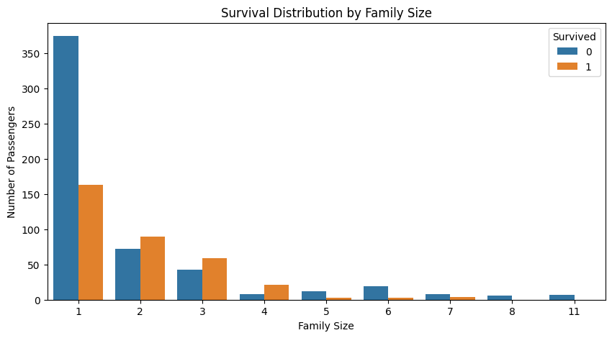

In [34]:
family_survival = (
df.groupby('FamilySize')['Survived']
.mean()
.mul(100)
.round(2)
)

print("Survival percentage by family size:")
print(family_survival)
Output:
Survival percentage by family size:
FamilySize
1 30.35
2 55.28
3 57.84
4 72.41
5 20.00
6 13.64
7 33.33
8 0.00
11 0.00
Name: Survived, dtype: float64

In [35]:
# One-Hot Encoding of categorical variables

df_encoded = pd.get_dummies(
df,
columns=['Sex', 'Embarked'],
drop_first=False,
dtype=int
)

print("Dataset shape before encoding:", df.shape)
print("Dataset shape after encoding:", df_encoded.shape)

df_encoded.head()
Output:
Dataset shape before encoding: (891, 12)
Dataset shape after encoding: (891, 15)

PassengerId
Survived
Pclass
Name
Age
SibSp
Parch
Ticket
Fare
FamilySize
Sex_female
Sex_male
Embarked_C
Embarked_Q
Embarked_S

0
1
0
3
Braund, Mr. Owen Harris
22.0
1
0
A/5 21171
7.2500
2
0
1
0
0
1

1
2
1
1
Cumings, Mrs. John Bradley (Florence Briggs Th...
38.0
1
0
PC 17599
71.2833
2
1
0
1
0
0

2
3
1
3
Heikkinen, Miss. Laina
26.0
0
0
STON/O2. 3101282
7.9250
1
1
0
0
0
1

3
4
1
1
Futrelle, Mrs. Jacques Heath (Lily May Peel)
35.0
1
0
113803
53.1000
2
1
0
0
0
1

4
5
0
3
Allen, Mr. William Henry
35.0
0
0
373450
8.0500
1
0
1
0
0
1

In [36]:
#categorical variables before and after encoding

print("Original categorical columns:")
print(df[['Sex', 'Embarked']].head())

print("\nEncoded columns:")
print(
df_encoded[
['Sex_female', 'Sex_male',
'Embarked_C', 'Embarked_Q', 'Embarked_S']
].head()
)
Output:
Original categorical columns:
Sex Embarked
0 male S
1 female C
2 female S
3 female S
4 male S

Encoded columns:
Sex_female Sex_male Embarked_C Embarked_Q Embarked_S
0 0 1 0 0 1
1 1 0 1 0 0
2 1 0 0 0 1
3 1 0 0 0 1
4 0 1 0 0 1

Interpretation of One-Hot Encoding

One-Hot Encoding converts categorical variables into binary numerical features.

For example:

- Sex_female = 1 indicates that the passenger is female.
- Sex_male = 1 indicates that the passenger is male.
- Embarked_C = 1 indicates that the passenger embarked from Cherbourg.
- Embarked_Q = 1 indicates Queenstown.
- Embarked_S = 1 indicates Southampton.

This transformation allows categorical information to be processed by machine-learning algorithms that require numerical input.

In [37]:
print("Correlation with Survived:")
print(
correlation_matrix['Survived']
.sort_values(ascending=False)
)
Output:
Correlation with Survived:
Survived 1.000000
Fare 0.257307
Parch 0.081629
PassengerId -0.005007
SibSp -0.035322
Age -0.069809
Pclass -0.338481
Name: Survived, dtype: float64

In [38]:
plt.figure(figsize=(8,4))

sns.boxplot(x=df['Fare'])

plt.title('Fare Outlier Analysis')
plt.xlabel('Fare')

plt.show()
Output:
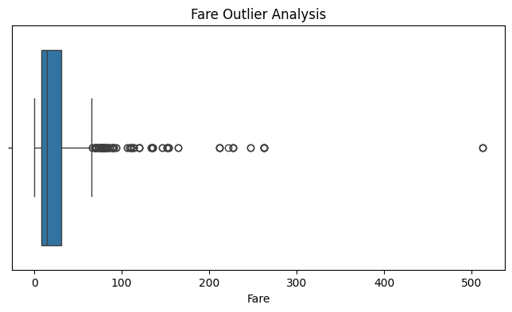

In [39]:
numeric_summary = df[
['Age', 'Fare', 'SibSp', 'Parch', 'FamilySize']
].describe().T

numeric_summary
Output:
count
mean
std
min
25%
50%
75%
max

Age
891.0
29.699118
13.002015
0.42
22.0000
29.699118
35.0
80.0000

Fare
891.0
32.204208
49.693429
0.00
7.9104
14.454200
31.0
512.3292

SibSp
891.0
0.523008
1.102743
0.00
0.0000
0.000000
1.0
8.0000

Parch
891.0
0.381594
0.806057
0.00
0.0000
0.000000
0.0
6.0000

FamilySize
891.0
1.904602
1.613459
1.00
1.0000
1.000000
2.0
11.0000

In [40]:
categorical_summary = pd.DataFrame({
'Unique Values': df[['Sex', 'Embarked', 'Pclass']].nunique(),
'Most Frequent': [
df['Sex'].mode()[0],
df['Embarked'].mode()[0],
df['Pclass'].mode()[0]
]
})

categorical_summary
Output:
Unique Values
Most Frequent

Sex
2
male

Embarked
3
S

Pclass
3
3

Key EDA Findings

Based on the exploratory analysis:

- The dataset contains 891 passenger records and includes both numerical and categorical variables.

- Cabin has a very high percentage of missing observations, making direct imputation unreliable. Therefore, it was removed during preprocessing.

- Age contains a considerable number of missing observations and requires imputation before machine-learning modelling.

- Embarked has only a very small number of missing observations and is imputed using its mode.

- Survival is not uniformly distributed across all passenger groups. Survival rates vary across gender and passenger class.

- Passenger class shows an important relationship with survival, which can be investigated through grouped survival percentages.

- Age distributions differ between passengers who survived and passengers who did not survive.

- Fare shows substantial variation and contains high-value observations that can be identified through boxplot analysis.

- Family size can be derived from SibSp and Parch and provides an additional feature for understanding passenger survival patterns.

- Correlation analysis provides an overview of relationships among numerical variables and helps identify potentially useful features for predictive modelling.

The EDA therefore provides evidence-based insights that can guide feature selection and subsequent machine-learning modelling.

In [41]:
#Normalization
df1 = pd.read_csv('wine_data.csv',header=None,usecols=[0,1,2])
df1.columns=['Class label', 'Alcohol', 'Malic acid']

In [42]:
df1.head()
Output:
Class label
Alcohol
Malic acid

0
1
14.23
1.71

1
1
13.20
1.78

2
1
13.16
2.36

3
1
14.37
1.95

4
1
13.24
2.59

In [43]:
sns.kdeplot(df1['Alcohol'])
Output:
<Axes: xlabel='Alcohol', ylabel='Density'>
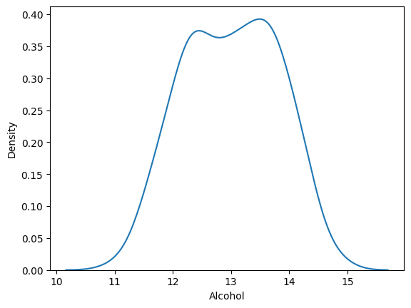

In [44]:
sns.kdeplot(df1['Malic acid'])
Output:
<Axes: xlabel='Malic acid', ylabel='Density'>
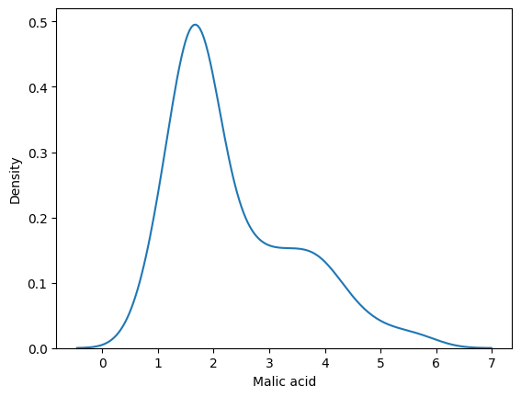

In [45]:
X_train, X_test, y_train, y_test = train_test_split(df1.drop('Class label', axis=1),
df1['Class label'],
test_size=0.3,
random_state=0)

X_train.shape, X_test.shape
Output:
((124, 2), (54, 2))

In [46]:
scaler = MinMaxScaler()

# fit the scaler to the train set, it will learn the parameters
scaler.fit(X_train)

# transform train and test sets
X_train_scaled = scaler.transform(X_train)
X_test_scaled = scaler.transform(X_test)

In [47]:
X_train_scaled = pd.DataFrame(X_train_scaled, columns=X_train.columns)
X_test_scaled = pd.DataFrame(X_test_scaled, columns=X_test.columns)

In [48]:
fig, (ax1, ax2) = plt.subplots(ncols=2, figsize=(12, 5))

ax1.scatter(X_train['Alcohol'], X_train['Malic acid'],c=y_train)
ax1.set_title("Before Scaling")
ax2.scatter(X_train_scaled['Alcohol'], X_train_scaled['Malic acid'],c=y_train)
ax2.set_title("After Scaling")
plt.show()
Output:
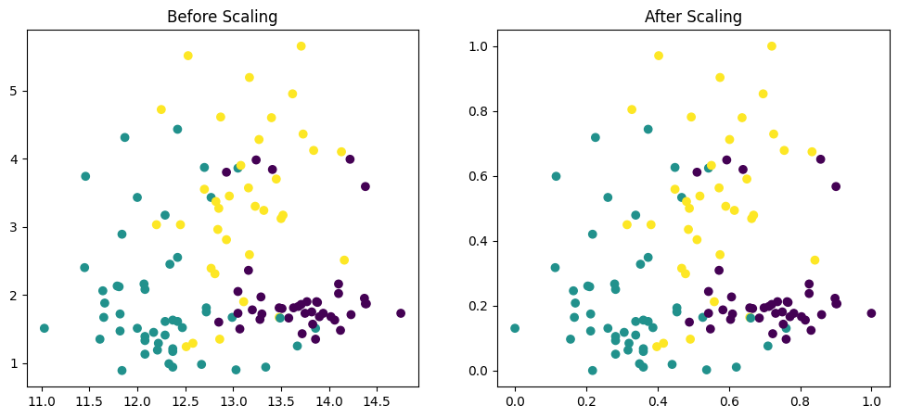

In [49]:
fig, (ax1, ax2) = plt.subplots(ncols=2, figsize=(12, 5))

# before scaling
ax1.set_title('Before Scaling')
sns.kdeplot(X_train['Alcohol'], ax=ax1)
sns.kdeplot(X_train['Malic acid'], ax=ax1)

# after scaling
ax2.set_title('After Standard Scaling')
sns.kdeplot(X_train_scaled['Alcohol'], ax=ax2)
sns.kdeplot(X_train_scaled['Malic acid'], ax=ax2)
plt.show()
Output:
